

SMART ATTENDANCE SYSTEM USING FACE RECOGNITION

MINOR PROJECT REPORT

Submitted in the partial fulfilment of the requirements for the award of the degree of  
BACHELOR OF TECHNOLOGY  
IN  
COMPUTER ENGINEERING



Submitted By Under the Supervision of

Nabeel Mohammad Rizwan (20BCS087) Professor Mohammad Amjad

Arsh Ali Khan (20BCS081)

**DEPARTMENT OF COMPUTER ENGINEERING FACULTY OF ENGINEERING & TECHNOLOGY JAMIA MILLIA ISLAMIA  
NEW DELHI (110025)  
(YEAR - 2023)**

**CERTIFICATE**

This is to certify that the project entitled “Smart Attendance System using Face Recognition” by Nabeel Mohammad Rizwan (20BCS087) & Arsh Ali Khan (20BCS081) is a record of bonafide work carried out by them, in the Department of Computer Engineering, Jamia Millia Islamia, New Delhi, under my supervision and guidance in partial fulfilment of requirements for the award of Bachelor Of Engineering in Computer Engineering, Jamia Millia Islamia in the academic year 2023.

**Prof. Bashir Alam Prof. Mohammad Amjad**

(Head of Department) (Professor)

Department of Computer Engineering Department of Computer Engineering

Faculty of Engineering & Technology Faculty of Engineering & Technology

Jamia Millia Islamia Jamia Millia Islamia

New Delhi New Delhi

**ACKNOWLEDGEMENT**

A very sincere and honest acknowledgement to Professor Mohammad Amjad, Department of Computer Engineering, Jamia Millia Islamia, New Delhi for his invaluable technical guidance, great innovative ideas and overwhelming support. We are very grateful to our HOD Prof. Bashir Alam for his valuable support throughout the project. We would also like to express our gratitude to the Department of Computer Engineering and entire faculty members, for their teaching, guidance and encouragement. We are also thankful to our classmates and friends for their valuable suggestions and support whenever required. We regret any inadvertent omissions.

Nabeel Mohammad Rizwan Arsh Ali Khan

(20BCS087) (20BCS081)

Department of Computer Engineering

Faculty of Engineering & Technology

Jamia Millia Islamia

New Delhi

**ABSTRACT**

Face recognition is one of the most used biometrics. It can be used for security, authentication, identification, and has many more advantages. Furthermore, face recognition systems can also be used for attendance marking in schools, colleges, offices, etc.

This system aims to build a class attendance system which uses the concept of face recognition as the existing manual attendance system is time consuming and cumbersome to maintain. And there may be chances of proxy attendance. Thus, the need for this system increases.

• Motivation

- There are a number of systems for attendance purposes, like traditional methods of data, they have drawbacks and are hard to use.

- There is also a chance of human errors and other errors like fingers being slippery etc in case of traditional attendance systems.

• Objective

- To create an efficient automated face recognition system with data storing capabilities.  
- To ensure that proxies are not registered and contactless, fast, accurate attendance.

• Methodology

- We have used Viola Jones (HAAR Cascade), CNN for face recognition (VGG FACE), CNN trained for binary classification problem of liveness check (frame is real or fake).

**TABLE OF CONTENTS**

| S.No. | Contents | | | | Page No. |
| --- | --- | --- | --- | --- | --- |
|  | CERTIFICATE | | | | 3 |
|  | ACKNOWLEDGMENT | | | | 4 |
|  | ABSTRACT | | | | 5 |
|  | TABLE OF CONTENT | | | | 6 |
|  | LIST OF FIGURES AND TABLES | | | | 8 |
|  |  | | | |  |
| 1 | INTRODUCTION | | | | 9 |
|  | 1.1 | What is Face Recognition | | | 9 |
|  | 1.2 | How Does Face Recognition work | | | 9 |
|  | 1.3 | What is Face Detection | | | 11 |
|  | 1.4 | Face Recognition vs Face Detection | | | 11 |
|  | 1.5 | Challenges | | | 12 |
|  | 1.6 | Applications | | | 13 |
| 2 | REVIEW OF LITERATURE | | | | 15 |
| 3 | THEORETICAL BACKGROUND | | | | 16 |
|  | 3.1 | | Viola Jones Algorithm | | 16 |
|  | 3.2 | | CNN – VGG Face, for face recognition | | 18 |
|  | 3.3 | | Liveness Detection using CNN | | 20 |
| 4 | PROPOSED METHODOLOGY | | | | 21 |
|  | 4.1 | | Basic Outline | | 21 |
|  |  | | 4.1.1 | Aim | 21 |
|  |  | | 4.1.2 | Programming Languages Used | 21 |
|  |  | | 4.1.3 | Programming Environment & Tools Used | 21 |
|  |  | | 4.1.4 | Algorithms Used | 21 |
|  |  | | 4.1.5 | Action | 21 |
| 5 | ANALYSIS OF RESULTS | | | | 23 |
| 6 | FUTURE WORK | | | | 26 |
| 7 | CONCLUSION | | | | 26 |
| 8 | REFERENCES | | | | 27 |

**LIST OF FIGURES AND TABLES**

| Fig / Table No. | Figure/Table Name | Pg No. |
| --- | --- | --- |
| FIG 1 | Generalized Architecture of face recognition attendance system | 10 |
| FIG 2 | Face Recognition & Detection functionalities | 12 |
| FIG 3 | Viola Jones Implemented on Phone camera | 16 |
| FIG 4 | Five Rectangular areas used by Viola Jones Algorithm | 17 |
| FIG 5 | Working of Viola Jones on a picture | 17 |
| FIG 6 | VGG 16 Architecture | 18 |
| FIG 7 | Process of training Liveness Net | 20 |
| FIG 8 | LivenessNet Architecture | 20 |
| FIG 9 | Face Recognition Pipeline Diagram | 22 |
| FIG 10 | Attendance Marking System | 22 |
| FIG 11 | Training and validation loss | 23 |
| FIG 12 | Training and validation accuracy | 23 |
| FIG 13 | Accuracy on test set | 23 |
| FIG 14 | liveness testing performed on Student | 24 |
| FIG 15 | Marking the Attendance | 25 |
| FIG 16 | excel file saved in drive with date | 25 |
| TABLE 1 | Face Recognition & Detection Functionalities | 11 |
| TABLE 2 | Review of Literature | 15 |
| TABLE 3 | Accuracy of VGG Face on different benchmark datasets | 19 |
|  |  |  |

**1. INTRODUCTION**

**1.1) What is Face Recognition**

Facial recognition is a technology that identifies or verifies an individual based on their face characteristics. It is a type of biometric technology, which means it uses unique biological characteristics to identify individuals. Facial recognition systems can be used to identify people in photos, videos, or in real-time.

Facial recognition systems work by analyzing a digital image of a person's face and comparing it to a database of faces. The system extracts features from the image, such as the distance between the eyes, the shape of the nose, and the contour of the face. These features are then compared to the features of the faces in the database. If there is a match, the system identifies the person in the image.

We have used CNN for Face Recognition in our project.

**1.2) How does facial recognition work?**

Many people are familiar with face recognition technology through the Face ID used to unlock iPhones (however, this is only one application of face recognition). Typically, facial recognition does not rely on a massive database of photos to determine an individual’s identity — it simply identifies and recognizes one person as the sole owner of the device, while limiting access to others.

Beyond unlocking phones, facial recognition works by matching the faces of people walking past special cameras, to images of people on a watch list. The watch lists can contain pictures of anyone, including people who are not suspected of any wrongdoing, and the images can come from anywhere — even from our social media accounts. Facial technology systems can vary, but in general, they tend to operate as follows:

Step 1: Face detection

The camera detects and locates the face in an image or a frame of a video, either alone or in a crowd.

Step 2: Face analysis

Next, an image of the face is captured and analyzed. Key factors include the distance between your eyes, the depth of your eye sockets, the distance from forehead to chin, the shape of your cheekbones, and the contour of the lips, ears, and chin. The aim is to identify the facial landmarks that are key to distinguishing your face.

Step 3: Converting the image to data

The face capture process transforms analog information (a face) into a set of digital information (data) based on the person's facial features. Your face's analysis is essentially turned into a mathematical formula. The numerical code is called a faceprint. In the same way that thumbprints are unique, each person has their own faceprint.

Step 4: Finding a match

Your faceprint is then compared against a database of other known faces.

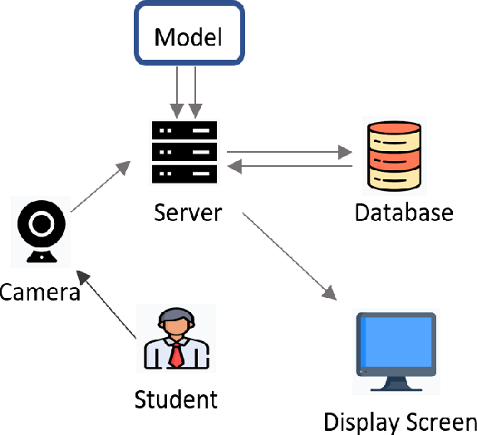

FIG 1: Generalized Architecture of face recognition attendance system

**1.3) What is Face Detection**

Face Detection is a part of Face Recognition. Face detection, also called facial detection, is an artificial intelligence (AI)- based computer technology used to find and identify human faces in digital images and video. Face detection technology is often used for surveillance and tracking of people in real time. It is used in various fields including security, biometrics, law enforcement, entertainment and social media.

Face detection algorithms typically start by searching for human eyes, one of the easiest features to detect. They then try to detect facial landmarks, such as eyebrows, mouth, nose, nostrils and irises. Once the algorithm concludes that it has found a facial region, it does additional tests to confirm that it has detected a face.

We have used Viola Jones algorithm for our minor project.

**1.4) Face Recognition vs Face Detection**

| Face Recognition | Face Detection |
| --- | --- |
| 1- A technology capable of identifying a person based on certain aspects of their physiology | 1- A technology used to identify and locate human faces in digital images and videos. |
| 2- The system uses biometrics to map facial features that are unique to an individual. | 2- The system identifies if there is a human face present within an image or video. |
| 3- The system can isolate a human face from others. | 3- The image is automatically processed to identify what is and is not a human face. |

TABLE 1: FACE RECOGNITION VS FACE DETECTION

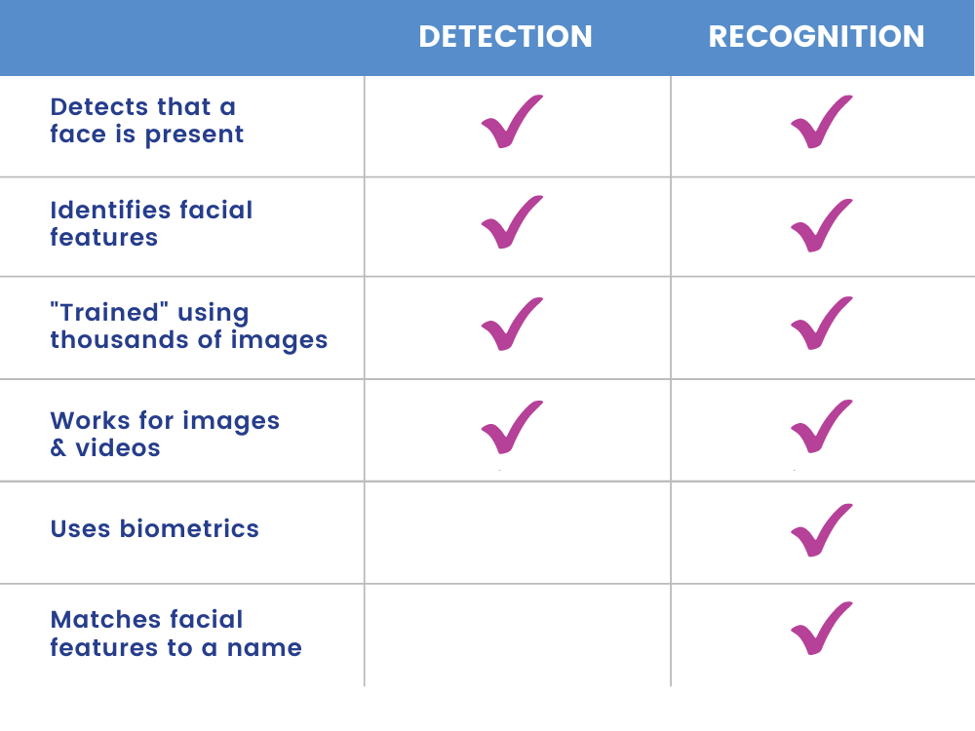

FIG 2: Face Recognition & Detection functionalities

**1.5 ) Challenges**

**Surveillance**

Some worry that the use of facial recognition along with ubiquitous video cameras, artificial intelligence, and data analytics creates the potential for mass surveillance, which could restrict individual freedom. While facial recognition technology allows governments to track down criminals, it could also allow them to track down ordinary and innocent people at any time.

**Scope for error**

Facial recognition data is not free from error, which could lead to people being implicated for crimes they have not committed. For example, a slight change in camera angle or a change in appearance, such as a new hairstyle, could lead to error.

**Breach of privacy**

The question of ethics and privacy is the most contentious one.

**Massive data storage**

Facial recognition software relies on machine learning technology, which requires massive data sets to “learn” to deliver accurate results. Such large data sets require robust data storage. Small and medium-sized companies may not have sufficient resources to store the required data.

**1.6) Applications**

**Unlocking phones**

Various phones, including the most recent iPhones, use face recognition to unlock the device. The technology offers a powerful way to protect personal data and ensures that sensitive data remains inaccessible if the phone is stolen. Apple claims that the chance of a random face unlocking your phone is about one in 1 million.

**Law enforcement**

Mobile face recognition allows officers to use smartphones, tablets, or other portable devices to take a photo of a driver or a pedestrian in the field and immediately compare that photo against one or more face recognition databases to attempt an identification.

**Airports and border control**

Facial recognition has become a familiar sight at many airports around the world. Increasing numbers of travellers hold biometric passports, which allow them to skip the ordinarily long lines and instead walk through an automated ePassport control to reach the gate faster.

**Finding missing persons**

Facial recognition can be used to find missing persons and victims of human trafficking. Suppose missing individuals are added to a database. In that case, law enforcement can be alerted as soon as they are recognized by face recognition — whether it is in an airport, retail store, or other public space.

**Reducing retail crime**

Facial recognition is used to identify when known shoplifters, organized retail criminals, or people with a history of fraud enter stores. Photographs of individuals can be matched against large databases of criminals so that loss prevention and retail security professionals can be notified when shoppers who potentially represent a threat enter the store.

**Banking**

Biometric online banking is another benefit of face recognition. Instead of using one-time passwords, customers can authorize transactions by looking at their smartphone or computer. With facial recognition, there are no passwords for hackers to compromise. If hackers steal your photo database, 'liveness' detection – a technique used to determine whether the source of a biometric sample is a live human being or a fake representation.

**Healthcare**

Hospitals use facial recognition to help with patient care. Healthcare providers are testing the use of facial recognition to access patient records, streamline patient registration, detect emotion and pain in patients, and even help to identify specific genetic diseases.

**Tracking student or worker attendance**

Educational institutions may use face recognition to ensure students are not skipping class. Tablets are used to scan students' faces and match them to photos in a database to validate their identities. More broadly, the technology can be used for workers to sign in and out of their workplaces, so that employers can track attendance.

**2. REVIEW OF LITERATURE**

| Sno | Paper | Summary |
| --- | --- | --- |
| 1 | Smitha, Pavithra S Hegde, Afshin.” Face Recognition based Attendance Management System”. ISSN: 2278- 0181.IJERT,2020 | Building a system of marking attendance using facial recognition. |
| 2 | Saptarshi Chakraborty, Dhrubajyoti Das (2014).An Overview of Face Liveness Detection,International Journal on Information Theory (IJIT), Vol.3 | A general overview of the techniques and methods used for facial recognition |
| 3 | Qiong Cao, Li Shen, Weidi Xie, Omkar M. Parkhi, Andrew Zisserman,VGGFace2: A dataset for recognising faces across pose and age, IEEE Conference on Automatic Face and Gesture Recognition (F&G), 2018. | Describes the dataset on which the model we use for facial recognition (VGG-FACE) was trained on |
| 4 | Omkar M. Parkhi,Andrea Vedaldi,Andrew Zisserman,Deep Face Recognition,Visual Geometry Group,Department of Engineering Science.University of Oxford, Deep Face Recognition  10.5244/C.29.41,2015 | Describes the architecture of the model we used for facial recognition.(VGG-Face) |
| 5 | Samana Jafri, Satish Chawan, Afifa Khan, Face Recognition using Deep Neural Network with “LivenessNet” 978-1-7281-4685-0/20/ , 2020 IEEE | Describes the model we used to detect liveness(livenessNet) |

TABLE 2: Review of Literature

**3. THEORETICAL BACKGROUND**

**3.1) VIOLA JONES ALGORITHM USING HAAR CASCADING**

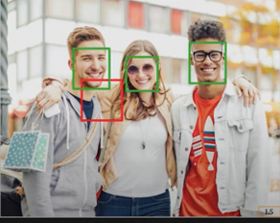

FIG 3: Viola Jones Implemented on Phone camera

* It is the most popular object detection algorithm of OpenCV.
* One of the primary benefits of Haar cascades is that they are very fast.
* It is used for face detection and not recognition.
* Real life application is used in old iphone models and still used in SnapChat.
* To obtain features for each of these five rectangular areas, we simply subtract the sum of pixels under the white region from the sum of pixels under the black region. Interestingly enough, these features have actual real importance in the context of face detection:

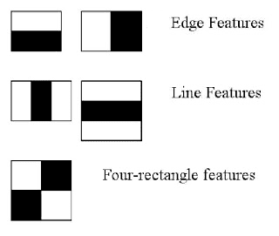

FIG 4: Five Rectangular areas used by Viola Jones Algorithm

1. Eye regions tend to be darker than cheek regions.

2. The nose region is brighter than the eye region.

* Therefore, given these five rectangular regions and their corresponding difference of sums, we can form features that can classify parts of a face.

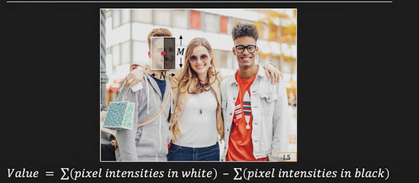

FIG 5: Working of Viola Jones on a picture

**3.2) CNN – VGG FACE, FOR FACE RECOGNITION**

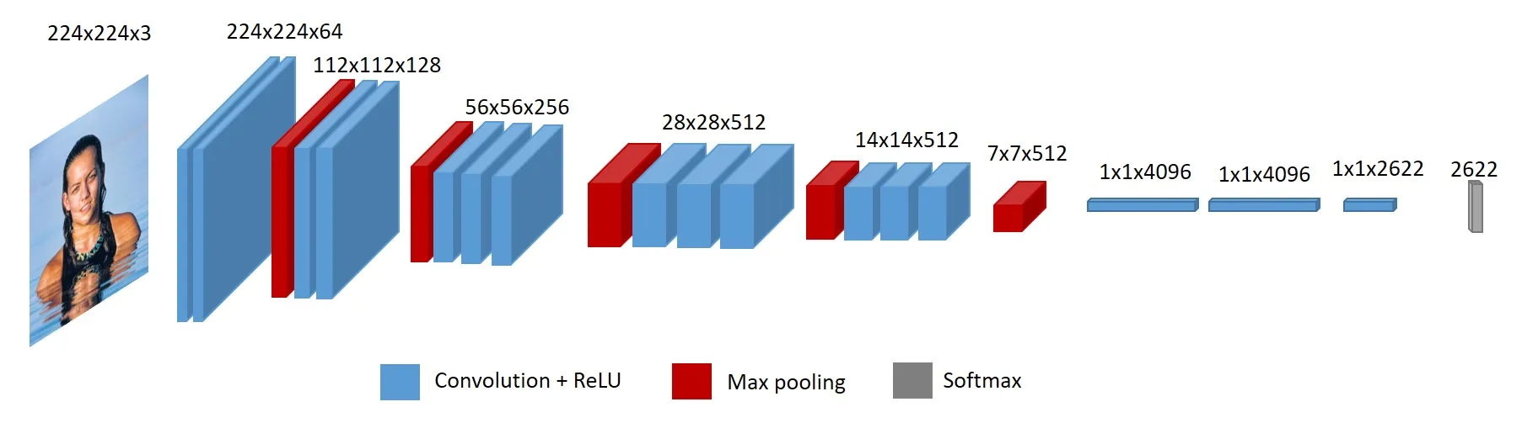

FIG 6:VGG FACE ARCHITECTURE

* Convolutional Neural Networks (CNNs) are a type of artificial neural network (ANN) that are particularly well-suited for image and video analysis tasks. They are inspired by the structure of the human visual cortex, which processes visual information in a hierarchical manner. CNNs consist of layers of neurons, each of which applies a convolution operation to its input
* VGG Face is a CNN architecture specifically designed for face recognition tasks. VGG Face is based on VGG Net, specifically the VGG16 architecture. VGG Face consists of 16 layers, including 13 convolutional layers , 5 max pooling layers and 3 fully connected layers. [4]
* The VGG Net architecture is composed of two main types of layers: convolutional and fully connected layers.
* Convolutional layers are the core building blocks of VGG Net, responsible for capturing local patterns and features from the input face image. The convolutional layers extract facial features at increasing levels of abstraction. The initial layers detect basic edges and textures, while the deeper layers identify more complex facial features, such as eyes, noses, and mouths.
* Fully connected layers, also known as dense layers, introduce connections between all neurons in one layer to all neurons in the next layer. They act as a higher-level processing stage, combining and transforming the extracted features from the convolutional layers.
* In summary, convolutional layers in VGG FACE capture local facial features, while fully connected layers combine and transform these features into a meaningful representation for face recognition.

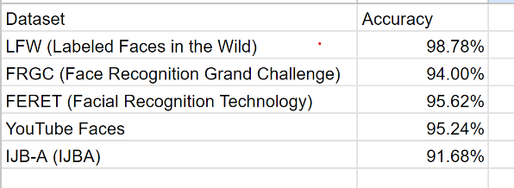

TABLE 3: Table of the accuracy of VGGFace on different benchmark datasets [3][4]

**3.3) Liveness Detection using CNN**

Dataset Used:Anti-Spoofing Dataset

Kucev Roman, 2500 real and spoofed Pictures from videos

It can be divided into 2 parts:

1. Extracting regions of interest (images) from videos (two videos – fake and real) and storing them as two different training datasets.

2. Using these datasets to train a Convolutional Neural Network named livenessNet to identify whether the frames provided by the live video camera are real or fake based on the training it received (binary classification problem). [5]

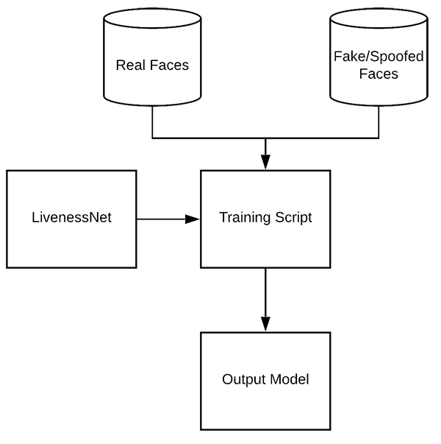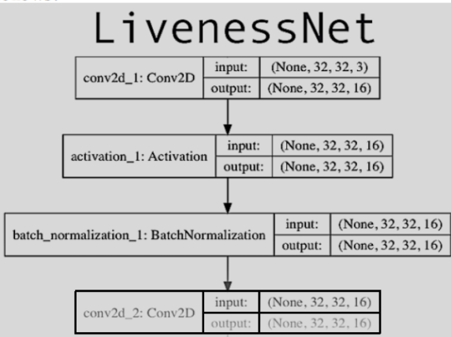

FIG 7: Process of training Liveness Net FIG 8: LivenessNet Architecture [5]

**4) PROPOSED METHODOLOGY**

**4.1) Basic Outline**

**4.1.1) Aim-** To make a contactless, fast, accurate attendance system using face recognition & detection technologies.

**4.1.2) Programming Languages used-** Python

**4.1.3) Programming Environment & Tools used-** VSCode, Excel, Google Collab,Kaggle,Jupyter Notebook,Google Drive, Webcam.

**4.1.4) Algorithms and models used-** Viola Jones Algorithm, VGG Face, LivenessNet.

**4.1.5) Action-**

* Before starting the recognition pipeline, pictures of each student/attendee are stored in a folder with their name.
* We Primarily use our in built camera or can use external camera to capture objects.
* Camera is enabled, Face detection occurs using Viola Jones Algorithm. This Algorithm provides fast detection of faces appearing on frame. However, It is used for face detection and not recognition.
* After detecting a face, Face recognition is done using CNN VGG Face. It creates representations of all the pictures stored and then compares them with the representation of the current face being identified[4], at the same time LivenessNet checks whether that face is real or is a picture from a device.[5]
* Once the face is identified, upon clicking enter, the name,date and the timestamp are marked in the live excel file. Upon attempting to mark the same person again, “already entered” is shown and the marking is not done again, thus ensuring security against double attendance.
* Finally, once the program is closed after all the attendance is over, it automatically sends the live excel file to the google drive server, where the name is kept as the current date.

FIG 9: Face Recognition pipeline Diagram

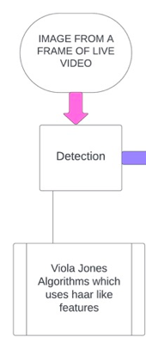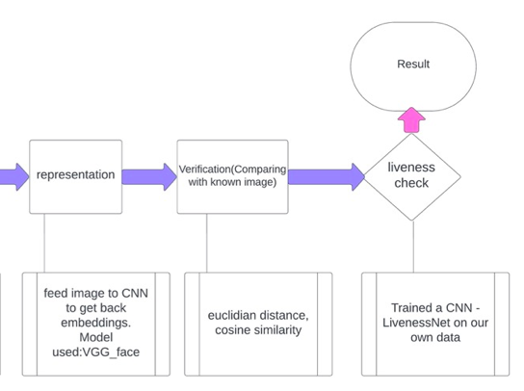

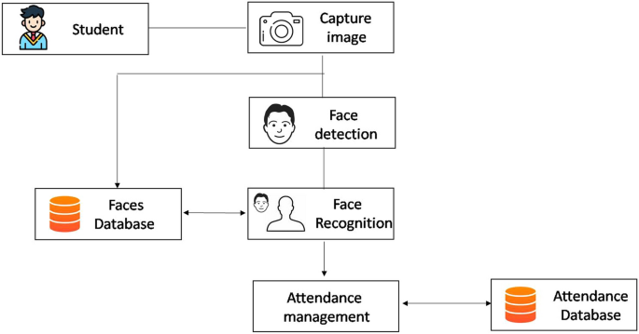

FIG 10: Attendance Marking System

**5. ANALYSIS OF RESULT**

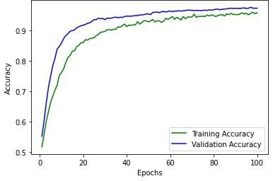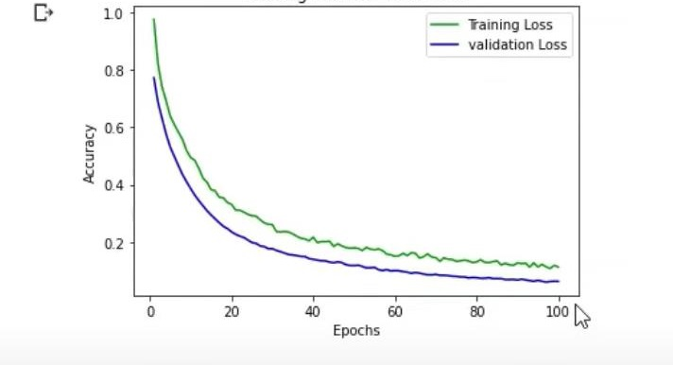

FIG 11: Training and validation loss FIG 12: Training and validation accuracy



FIG 13: Accuracy on test set

| Total pictures in testing directory | False Positives | False negatives |
| --- | --- | --- |
| 478 | 19 | 6 |

| Error Rate | Success Rate |
| --- | --- |
| 2.62% | 97.37% |

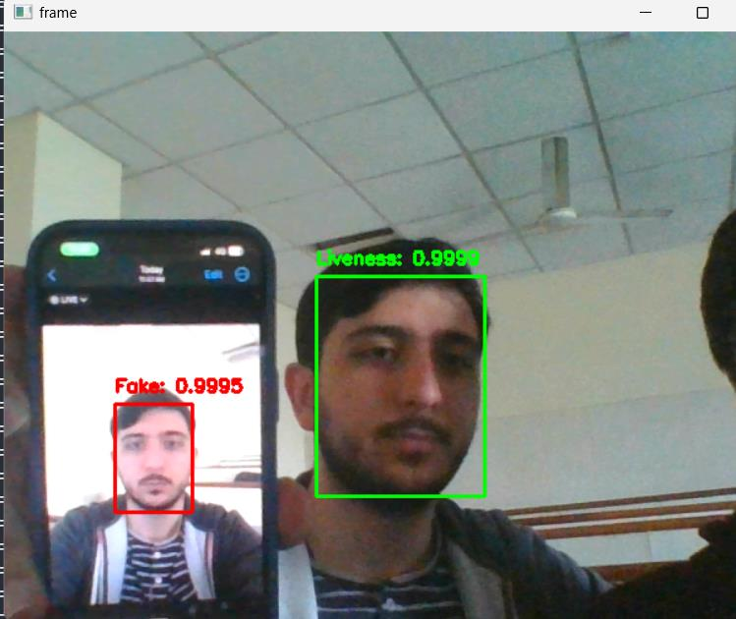

FIG 14: liveness testing performed on student

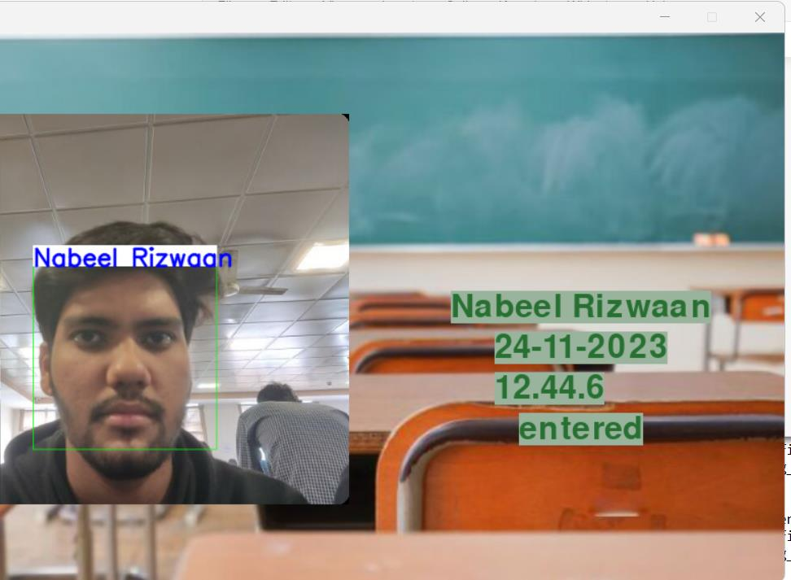

FIG 15: Marking the Attendance



FIG 16: excel file saved in drive with date

**6. FUTURE SCOPE OF RESEARCH AND WORK**

* Increasing the effectiveness of the livenessNet CNN by using a larger and more diverse dataset comprising of different ethnicities, skin colors and ages[2]
* Finding ways to reduce the computation complexity of adding attendance data real time to a live database stored on cloud instead of first on a local machine.
* Real-Time Database may be used in future with frontend. This project may be used as an API.
* Using one-shot/few-shot learning techniques to minimize training images with few images making it more optimized.

**7. CONCLUSION**

* We made an efficient system that can detect fake and real faces, and also mark attendances based on the initial images provided.
* We were able to achieve constructive results.
* It arranges data with date and time on excel sheets to easily be accessible by anyone.
* We Used a highly accurate model VGG FACE to implement face recognition.
* For liveness detection we trained and used the livenessNet model.

**8. REFERENCES**

[1]Smitha, Pavithra S Hegde, Afshin.” Face Recognition based Attendance Management System”. ISSN: 2278- 0181.IJERT,2020

[2]Saptarshi Chakraborty, Dhrubajyoti Das (2014).An Overview of Face Liveness Detection,International Journal on Information Theory (IJIT), Vol.3

[3] Qiong Cao, Li Shen, Weidi Xie, Omkar M. Parkhi, Andrew Zisserman,VGGFace2: A dataset for recognising faces across pose and age, IEEE Conference on Automatic Face and Gesture Recognition (F&G), 2018.

[4] Omkar M. Parkhi,Andrea Vedaldi,Andrew Zisserman,Deep Face Recognition,Visual Geometry Group,Department of Engineering Science.University of Oxford, Deep Face Recognition

10.5244/C.29.41,2015

[5] Samana Jafri, Satish Chawan, Afifa Khan, Face Recognition using Deep Neural Network with “LivenessNet” 978-1-7281-4685-0/20/ , 2020 IEEE